Lab Exercise 8- Creating a Multi-Container Pod

Steps to be followed:
- Create and access a multi-container pod

Step 1: Create and access a multi-container pod

- Create a YAML file using the following command:
multi-pod.yaml

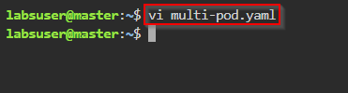

- Enter the following code into the multi-pod.yaml file and then save it:

apiVersion: v1
kind: Pod
metadata:
name: multicontainer-pod
spec:
containers:
#Container 01
- name: web
image: nginx
ports:
- containerPort: 80
#Container 02
- name: redis
image: redis
ports:
- containerPort: 6379

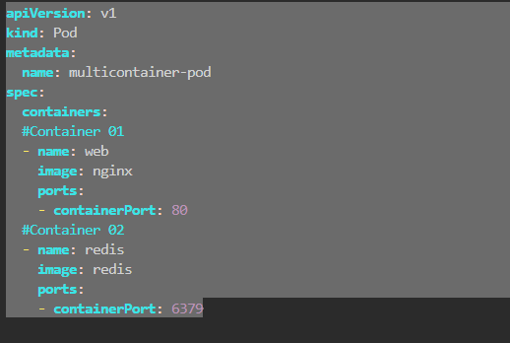

- Create the pod using the following command:
kubectl apply -f multi-pod.yaml

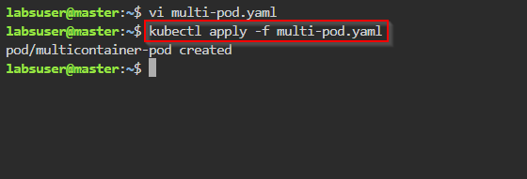

- Execute the command inside the web container of the multicontainer-pod to display the date and time:
kubectl exec -it multicontainer-pod -c web -- date

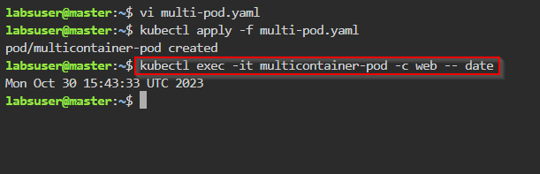

- Execute the command inside the redis container of the multicontainer-pod to display the date and time:
kubectl exec -it multicontainer-pod -c redis -- date

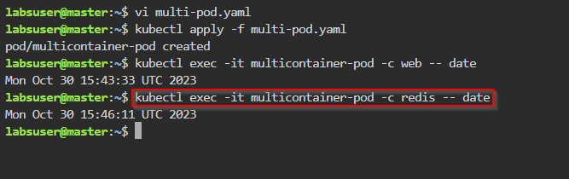

- To view the logs of the web container, use the following command:
kubectl logs multicontainer-pod -c web

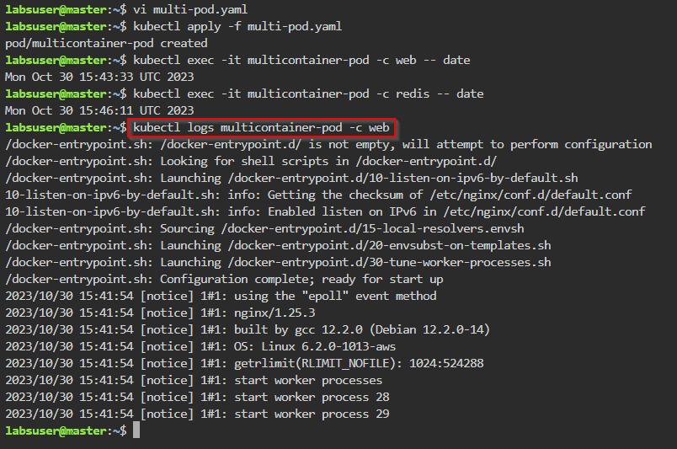

- View the logs of the redis container using the following command:
kubectl logs multicontainer-pod -c redis

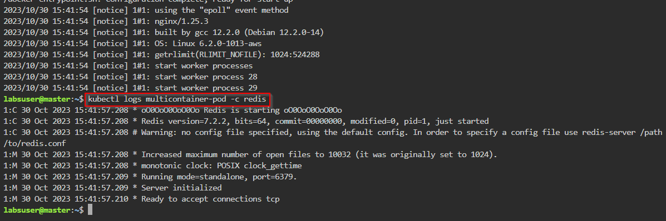

Note: When working with a pod that contains only one container, the -c flag is not necessary. However, for multi-container pods, specifying the container is crucial.

By following these steps, you have successfully established a multi-container pod within a Kubernetes cluster.

